ASSIGNMENT 03

K.VIGNANAND RAO - BATCH 41 - 2303A52439

TASK 01
PROMPT:
Python code which collect the data, reads it accurately (Previous units, current units and type of customer (domestic, commertial or industrial consumers)) and calculates the units consumed and displays it, no functions used, create 6 customers details in code itself with columns, serial number, name, cust id, previous units, current units and type of customer.
CODE:
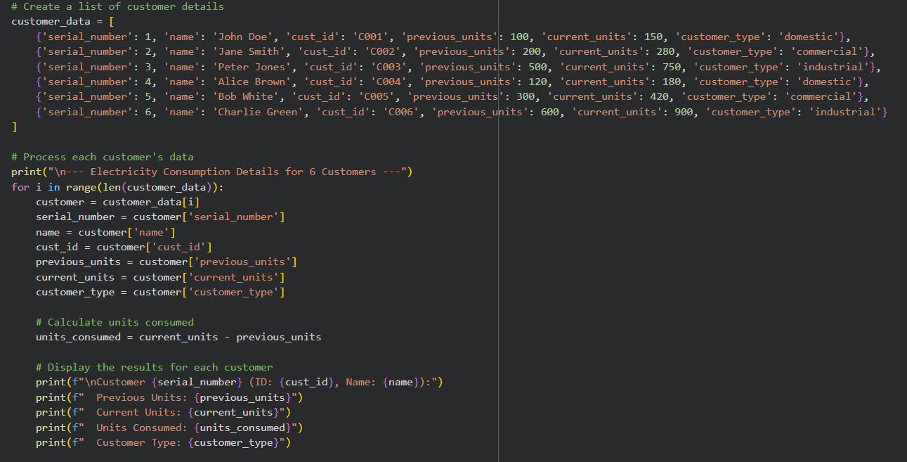

OUTPUT:
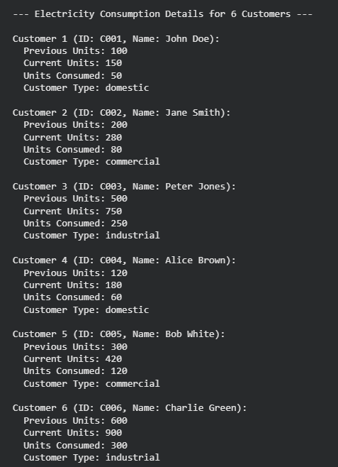
JUSTIFICATION:
In this activity or task, we are able to read all the data accurately and perform required actions well by using gemini ai.

TASK 02
PROMPT:
Generate a optimized python code which calculates the electricity bill based on type of customers using conditional statements
CODE:
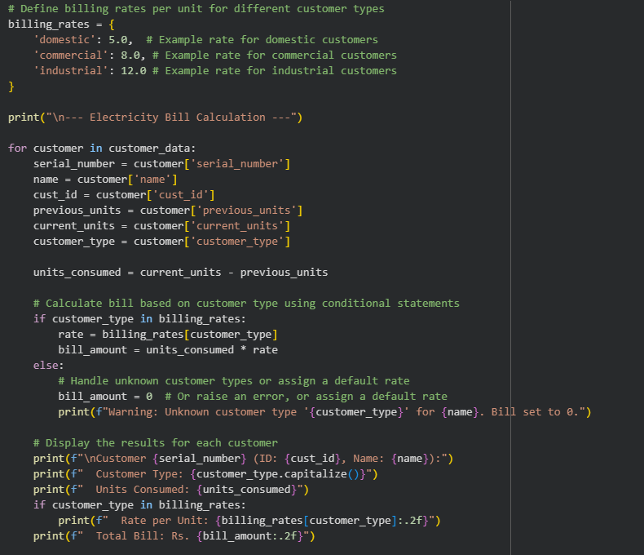

OUTPUT:
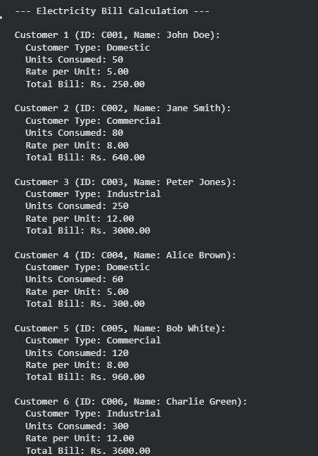
JUSTIFICATION:
In this task we are calculating the electricity bill on the basis of type of customer we are having.

TASK 03
PROMPT:
A python code to calculate energy charges and fixed charges using functions and can be reused by multiple customers and return values, also include comments
CODE:
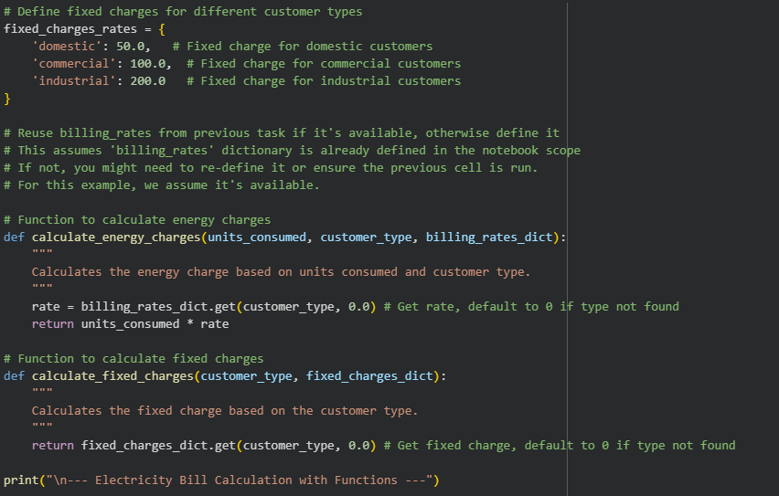
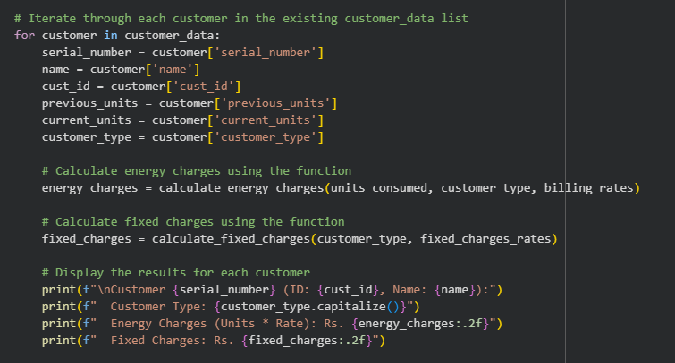
OUTPUT:
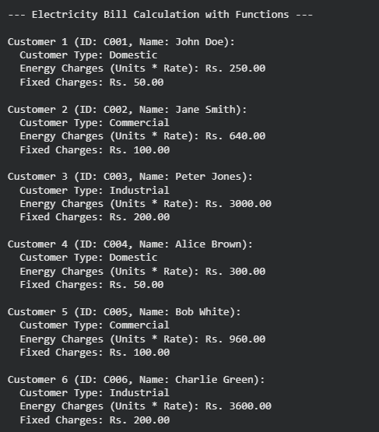
JUSTIFICATION:
In this task not only calculating the energy charges, we are also adding the fixed charges to each customer using functions, we are also adding the required comments for better understanding and easy readability.

TASK 04
PROMPT:
Add additional charges like fixed charges, customer charges, electricity duty (percentage of EC) and improve billing accuracy
CODE:
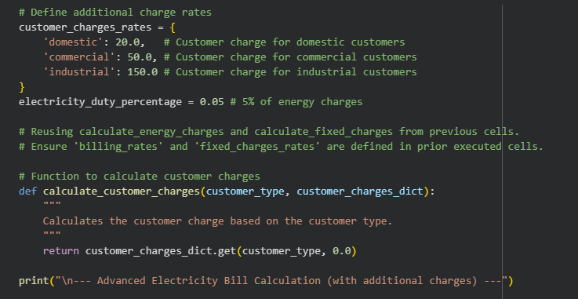
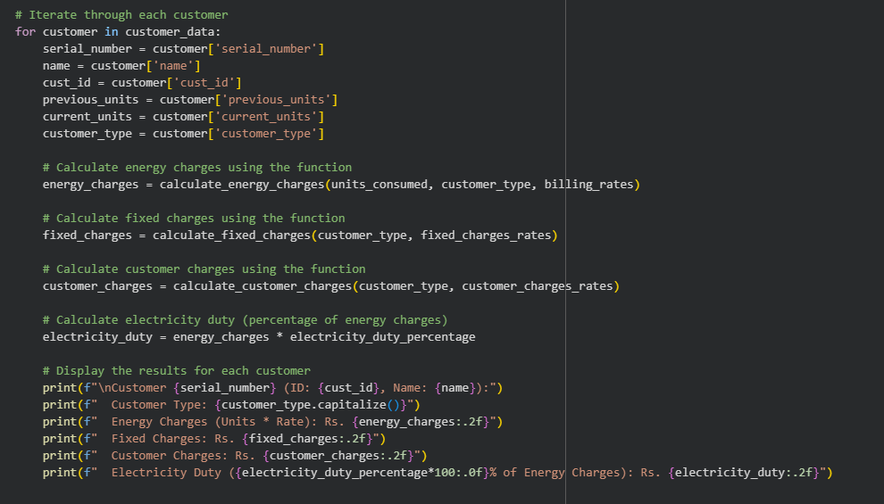
OUTPUT:
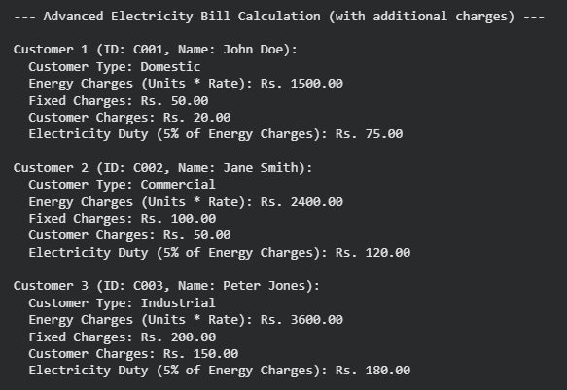
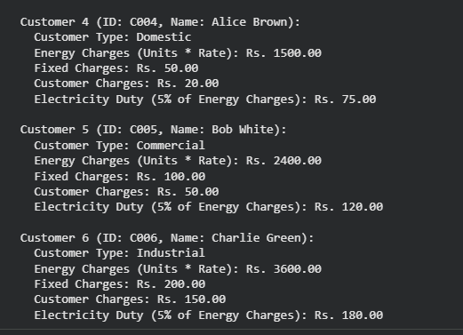
JUSTIFICATION:
In this task we are also adding few other charges to bill like Customer charges, Electricity Duty(5% of Energy Charges). We have done this using functions and required comments were kept for easy understanding purpose.

TASK 05
PROMPT:
Display the final bill clearly with each charges, total bill is sum of EC, FC, CC, ED
CODE:
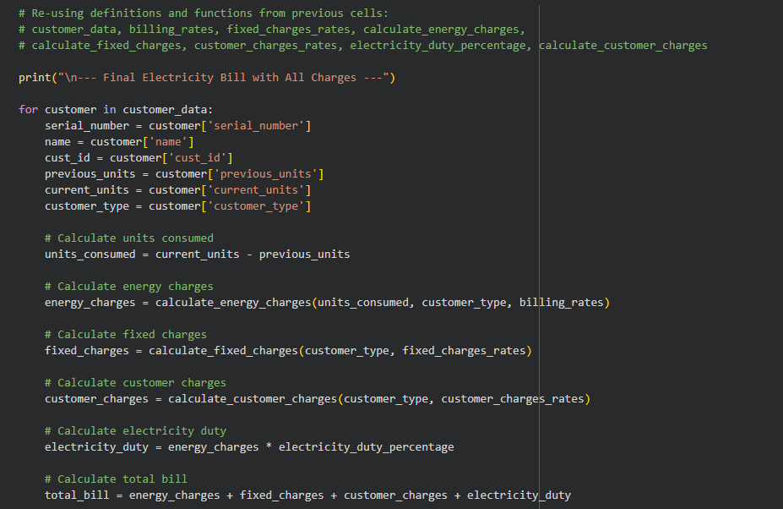
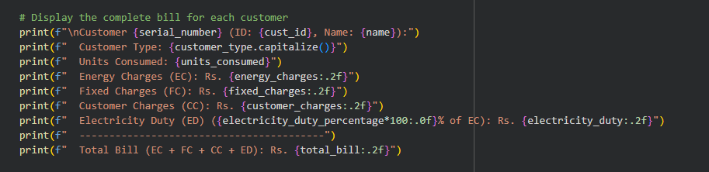

OUTPUT:
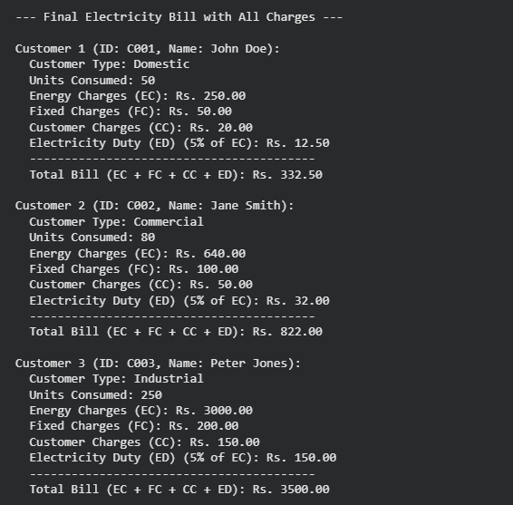
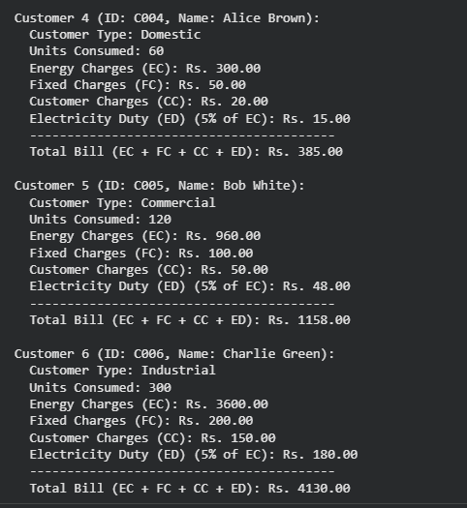
JUSTIFICATION:
Here, in this task we are finally printing the total bill in perfect arrangements and with full details.

